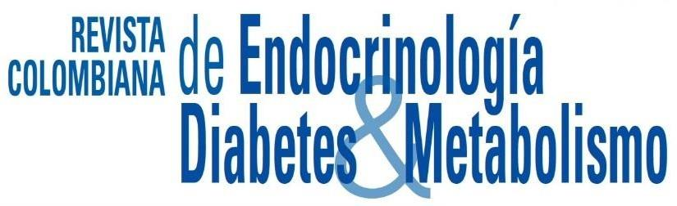

Copyright form
Revista Colombiana de Endocrinología, Diabetes y Metabolismo

E-ISSN: 2805-5853 L-ISSN: 2389-9786

- About the manuscript

Type of Article:Elija un elemento.
Article Name:
Author(s):

Accepted manuscripts cannot be published unless this letter is completed, signed and returned to the journal. This letter and its terms cannot be modified.

The undersigned author(s) DECLARE(S) that:

- The submitted work is an original work.
- It has not been previously published.
- It has not been submitted simultaneously to another publication.
- Is responsible for all intellectual property rights involved in its realization and, if applicable, has the permission of all authors involved in its development.
- It has made the bibliographical references in a concise and complete way.
- This article does not violate any right of publication or property, or rights of third parties and that you agree to hold the journal free of blame in case there is any claim concerning your manuscript.
- You grant the journal the right to make changes to your manuscript, including the title of your manuscript for brevity, clarity, and conformity of style.
- At the time of publication, all copyrights are transferred to the Revista Colombiana de Endocrinología, Diabetes y Metabolismo, for the entire term of legal protection and in all territories, without whose express permission none of the materials presented in this work may be reproduced.
- Through this document and if the work is published in its final version in this journal, the Colombian Association of Endocrinology, Diabetes and Metabolism, assumes the rights to edit, publish, reproduce, distribute copies, prepare derivative works in paper, electronic or multimedia and include the work in national and international indexes or databases. If for any reason the journal as a whole or your article is not published, your manuscript will be returned to you with the understanding that you are free to use it in any way you wish.
- You will receive one (1) copy of the journal as a courtesy.

Certification of Authorship (all authors must sign this section)
All authors must provide their original signature on this document. For authors who cannot be contacted in person, it will be sufficient to send the scanned document by e-mail to revista@endocrino.org.co

By signing, the author(s) agree: (1) to the ten terms mentioned in this letter; (2) to defend and hold harmless the Revista Colombiana de Endocrinología, Diabetes y Metabolismo, for any claims against it arising from this publication; and, (3) to approve the order in which each author will appear in the final version of the article.

Author 1

FULL name without using abbreviations |  | Sign |  | Date

Author 2

FULL name without using abbreviations |  | Sign |  | Date

Author 3

FULL name without using abbreviations |  | Sign |  | Date

Author 4

FULL name without using abbreviations |  | Sign |  | Date

Author 5

FULL name without using abbreviations |  | Sign |  | Date

